The
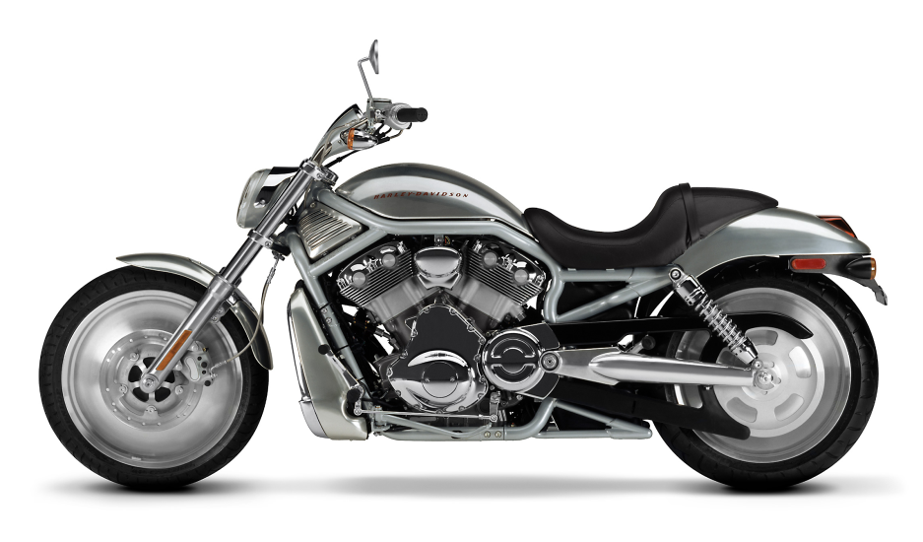
Creation
Of
A
Harley
Davidson

Aaron Kelley
04-27-08
MEEG 453

Summary:
Harley Davidson motorcycles, a true American tradition, are built with that single goal in mind. With factories exclusively in the U.S., Harley has an annual output of over 300,000 motorcycles with revenue of approximately six billion dollars. The following report will outline the manufacturing process that takes place in York, Pennsylvania. The objective is to explore an uncharted area of manufacturing which is of interest to the author, and furthermore to provide beginning and mature engineers with information significant to their level of expertise.

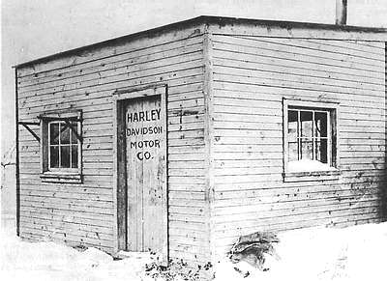
Harley-Davidson began in 1903 when William S. Harley and the two Davidson brothers – Walter and Arthur – handcrafted their first three motorcycles in Milwaukee, Wisconsin. Since then the company has endured two World Wars, a depression, multiple recessions, mergers and buyouts, government animosity, and public and private ownership. Harley-Davidson accomplished this feat not only through great management, but through strategic and innovative manufacturing practices.
Fig. 1
The Process
In York, PA , at the Vehicle Operations center (VO), 3,200 employees manufacture and assemble Touring and Softail models, along with limited factory-custom models. Many different processes take place within the VO, including forming, welding, machining, pressing, plating, polishing, and painting, in addition to the assembling and testing of motorcycles. It takes approximately two hours to completely assemble a motorcycle at this factory.
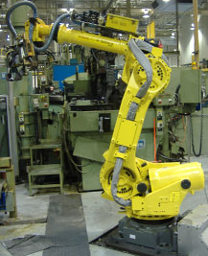
Phase I: Forming, Welding, and Machining of Gas Tank, Fenders, and Small Parts
The first part of the plant manufactures the gas tank, front and rear fenders, and small parts such as brackets and kickstands. Pure American made rolls of steel are shipped to the plant from Worthington Steel (Columbus, Ohio) and organized on the floor. These individual rolls are then unwound on a machine which then feeds a continuous stream of sheet steel to many different zones, ready to be cut and formed.
Fig. 2
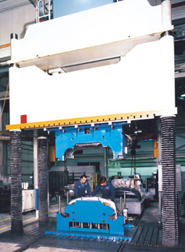
Front and Rear Fenders
Fig. 3
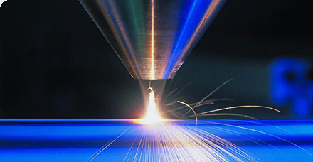
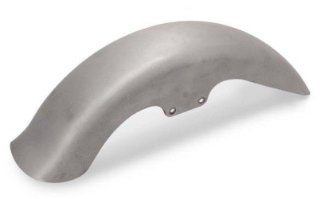
The steel used in this process is flexible steel and is different from the others, due to the fact that it needs no heat treating prior to forming. A certain dimension of sheet steel is cut and subsequently fed to a deep draw two-way (both the top and bottom compress) robotic press capable of producing up to 750 parts per hour. Once the fender is formed, a shimmy shear is used to trim excess metal, which is then collected in a bin to be recycled. Shaping the rear fender differs in that the pressing is done manually (due to an intricate design). The rear fender, once formed, is sent to a station where holes are punched out (to run wires for brake light, etc.), contours are formed, and hemming takes place automatically through laser beam welding, taking only two and a half minutes to complete. The cut of a laser beam weld is so accurate and smooth that there are no subsequent sanding/polishing processes needed. The fenders are then sent to the paint station.
Fig. 4
Fig. 5
Gas Tanks
Here the sheet steel once again dimensioned, cut, and fed automatically to a deep draw process and pressed with a robotic arm retrieving the formed halves and sending them to a shimmy shear to be trimmed. Next, the halves are welded together either automatically or manually depending on the model. The tank is then sent to be painted.
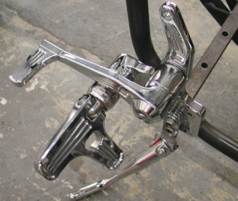
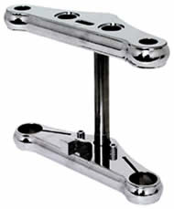
Small Parts (Bumpers, Brackets, Kickstands)
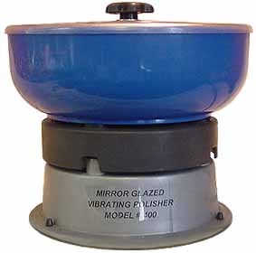
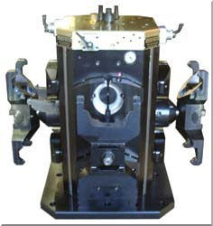
Front and rear bumpers are constructed through tube bending and then manually brazed for a very clean weld. For the manufacturing of kickstands and jiffy stands, a solid steel rod approximately a foot in length and 3 inches in diameter is placed into a heat oven and its temperature is raised to 2000 deg F. The part is subsequently pressed, using a specific die depending on the type of part being produced. Brackets—specifically fork brackets—are manufactured by machining a pre-formed part. The pre-formed part is sent to Harley-Davidson from another manufacturer, clamped in a “tombstone” in a machining center and is pressed to enhance its features (typically addition of holes) and to increase levels of detail. The bracket will then go to polishing and chroming (see below). For miscellaneous parts, a robotic arm grabs the piece of the sheet steel being conveyed and places it into a progressive press. This press produces forces up to 400 tons and can switch between many different dies, depending on the type of bracket/part. Note that this operation presses multiple times for an individual piece. There are also many other miscellaneous operations which are utilized if needed such as industrial parts washing. If a part needs to be chromed they are first polished in a vibratory polisher (a large drum filled with either ceramic or high density polymeric objects) then plated with a few coatings of nickel (the most prominent agent in chroming), and then finished off with a coating of chromium. Interestingly enough, parts used to be polished manually, but due to medical problems revolving around repetitiveness, high cost, and long amounts of time, it has since become automated.
Fig. 6
Fig. 7
Fig. 8
Fig. 9

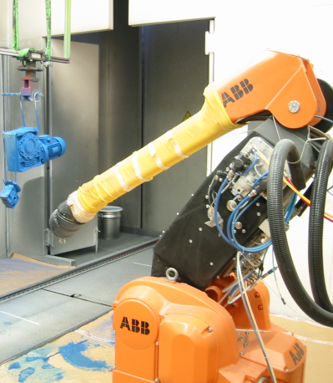
Phase II: Painting
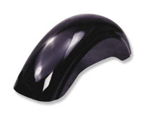
All parts to be painted are first collected in bins after all phase I processes and sent to the paint department through mechanical conveyors and special elevators. Once in the paint department, time varies between seven hours for one coating to twelve hours for two coatings. The automated paint machines/robots are able to changeover to different colored paints within thirty seconds with no bleeding on the painted surface. After a part is completely coated it is racked and dried. Once parts are completely dried, they are inspected for scratches and other defects which (even the most minor) are then buffed out. If a scratch is so bad as to retain visibility after buffing, the part is discarded and recycled.
Fig. 10
Fig. 11
Phase III: Motorcycle Assembly
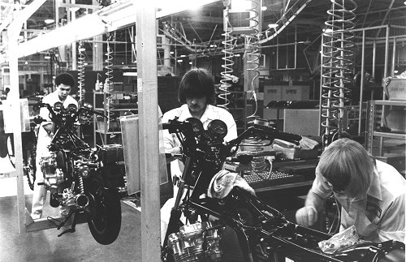
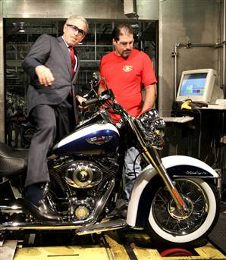
Now that parts are formed, welded, machined, polished, and/or painted (or chromed), they are once again sent from their last station to a final station, which can be anywhere along an assembly line, where they will be manually added to the motorcycle. This assembly line comprises of forty-eight individual stations, each equipped with a sub-assembler (a human worker) and the tools and parts each station needs to complete their required task. There are approximately 2,000 parts added to the frame during this process. The assembly line begins where the motorcycle frame is removed from a storage cart and attached to a “J-bar” which is suspended from an overhead trolley. The trolley moves with a speed of 6 feet/min, enough time that the sub-assemblers at each station can complete their task. A few important stations include station 22, where the motorcycle is inspected for proper assembly, and station 24, where a cosmetic check is performed. Concerning wheel and tire assembly, there are two options for wheels for any motorcycle being assembled: cast and laced. The wheels and tires are organized in blue, yellow, and orange carts and sent to their respective sub-assembly stations. Once the motorcycle is fully assembled, it goes through roll testing (this is done to every single unit) where an employee places the motorcycle wheels on two free spinning rollers anchored in the floor (to prevent the bike from moving) and drives it for a mile and a half to test for any last minute mechanical or electrical faults. Random bikes are then selected for testing on a highway surface, where the bike is driven for approximately twenty-five miles. We were told that these are the two largest jobs in demand and there is a huge waiting list.
Fig. 12
Fig. 13

Business and Technical Aspects
Fig. 14
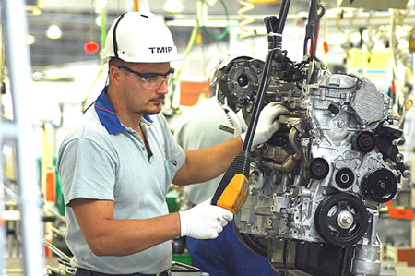
Although many economic and business aspects were not covered in the tour, some ideas were gathered through identifying different work patterns. The factory had a desirable trade-off between manual and automatic labor. Comparing the assembly of motorcycles (which is almost all manual work) and the processing of parts, the amount of the two is about even. This is more desirable from a political, broader point of view in that it creates jobs for the community while keeping a reputable and profitable company with quality, world known products. Harley made it known that it focuses on quality, not quantity. Some technical aspects other than manufacturing basics were observed and are given below.
Ergonomics
The tour guide made it very clear that workers are the number one asset to Harley-Davidson. The least amount of evidence to this is the fact that employees either leave through retirement or by being dragged out by their feet. Technically speaking, employees go through extensive training and specialization, are required to wear ear/eye protection in the proper areas, and are made self conscious of accidents through posting safety incident boards. In addition, employees are given an ample lunch and various breaks, provided with special pricing/financing on new motorcycles, and their job responsibilities are exchanged every hour to two hours to reduce monotony and boredom which leads to low productivity and a potentially high rate of defects. All of these factors (and more) revolve around employee contentment.
Quality
The majority of Harley-Davidson’s quality methods were made through inspection, making sure a part meets expectations. Parts which did not pass inspection where recorded and then the physical part is placed on display with the defect noted beside it. Additionally, every motorcycle is inspected halfway through assembly for technical and cosmetic accuracy, and once the motorcycle is completed, each goes through an extensive roll test to ensure it is assembled properly with no defects from assignable variations. As it is known world-wide, Harley-Davidson makes quality products and has very few defects compared to other manufacturers in its same industry.
Material Handling
Fig. 15
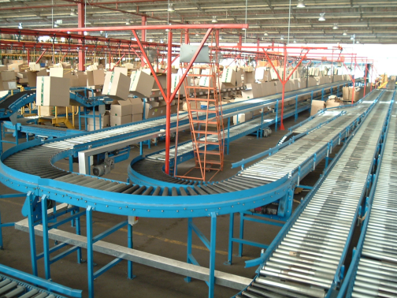
Sheet steel to be formed was transferred using conveyor belts, gravity and/or chain rollers. A robotic arm or employee transferred the dimensioned and cut steel to the specific press. Finished formed parts such as fenders were transported using carts, belts, and/or elevators. Many small parts were either stored and transported in bins or hung on carts with special types of hooks. Bulk solids such as scrap metal, nuts and bolts, and small brackets were stored and transported mostly in bins. Wheels and tires were organized in different colored carts (blue, yellow and orange) for organization. All bins and carts were either pushed manually or pulled by trucks. Painted products were hung or stored on large shelves and typically transported by hand thereafter. Once the motorcycle assembly began, the frame was attached to a j-bar which was suspended from an overhead trolley. There are many other types of handling which was utilized but we did not see since the tour was limited and the factory is very extensive.
Relevance for Beginning and Mature Engineers
The major significance of this topic for a beginning engineer is the understanding of the basics of vehicle manufacturing and assembly. Furthermore, Harley-Davidson kept all processes simple and to a minimum, and understanding this is very important for a beginning engineer. In addition, many different aspects of manufacturing are pointed out in a practical setting, including material handling, forming and machining, welding, quality, ergonomics, and economics.
The major significance for a mature engineer is the concept of employee happiness. Any engineer who has a task of designing/analyzing manufacturing systems should keep in mind the quality of work for the hands on workers. The level of their environment will reflect in the finished product.
Learning
The importance of quality versus quantity, which is closely related to automation versus manual operation, is the most significant aspect I learned from this experience. Harley-Davidson, a manufacturing company with a relatively high rate of manual labor, produces motorcycles known throughout the world with very high quality and performance and a reputation which justifies these characteristics. The entire assembly process is manual, while the manufacturing processes were fairly even. To provide such quality products, while maintaining and providing jobs for society and keeping a significant net income of 1 billion dollars is an enormous feat. From here, I will remember to always analyze tradeoffs between automation and manual labor, to not focus exclusively on long term operating costs optimized through automation, but look at factors such as greater flexibility and higher potential quality incurred with manual labor, which has a much greater impact on company success.

References
Images (Fig #):
Title Page: BikerOne. http://www.bikerone.com/images/VRSC51.jpg

- Old Car and Truck Pictures.
http://harley-davidson.oldcarandtruckpictures.com/Harley_Davidson_Factory_1903.jpg
- McAlister Design. http://www.mcalisterdesign.com/images/robotic-arm.jpg
- TheFabricator.com. http://www.thefabricator.com/Articles/Photos/226/lead.jpg
- MTU Aero Engines. http://www.mtu.de/de/technologies/repair_techniques/laser_powder_cladding/laserpulver_schweissen.jpg
- BikerHaven-Wholesale. http://www.bikerhaven.net/fender.jpg
- Steel Thunder Custom Cycles. http://www.steelthundercc.com/assets/tripletrees_handlebars_risers%20assets/36286.jpg
- Bandit’s Bikernet. http://www.bikernet.com/news/images/PhotoID10919.jpg
- Pro Hold. http://www.prohold.com/std_hyd_tombstones.htm
- English Custom Polish. http://www.englishcustompolishing.com/usca/vibratory.html
- Flex Paint. http://www.flexpaint.org/download/Gallery_1002/Photos/Paint_Robot_Setup.JPG
- O’Hara Restorations. http://www.ohararestorations.com/assets/images/maierfender.jpg
- The International CBX Owners Association. http://www.cbxclub.com/marysville80.html
- MSNBC. http://www.msnbc.msn.com/id/14380131/
- Invest in Poland. http://www.paiz.gov.pl/nowosci/?id_news=645&lang_id=1
- Conveyco. http://www.conveyco.co.za/images/Home_Page/Front_Page02.JPG

References
Literature:
- Harley-Davidson, Inc. Harley-Davidson Unaudited Historical Data. http://investor.harley-davidson.com/downloads/factsheet.pdf?locale=en_US&bmLocale=en_US
- Harley-Davidson, Inc. Harley-Davidson Historical Milestones. http://investor.harley-davidson.com/downloads/bckgrdr.pdf?locale=en_US&bmLocale=en_US

